1. Login to current azure portal manage.windowsazure.com
2. Select New from bottom left  
   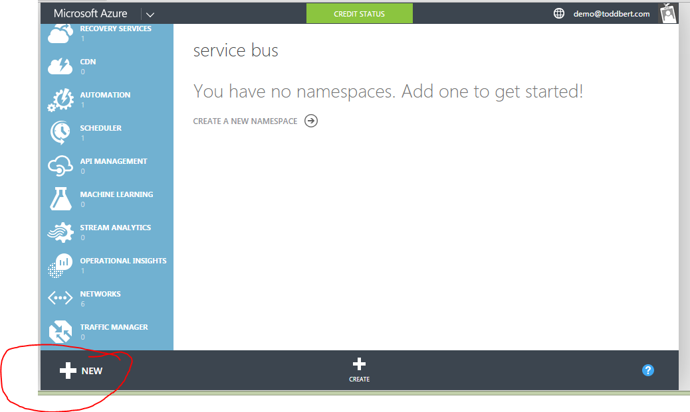
3. Select Service Bus -> Event Hub -> Quick Create  
   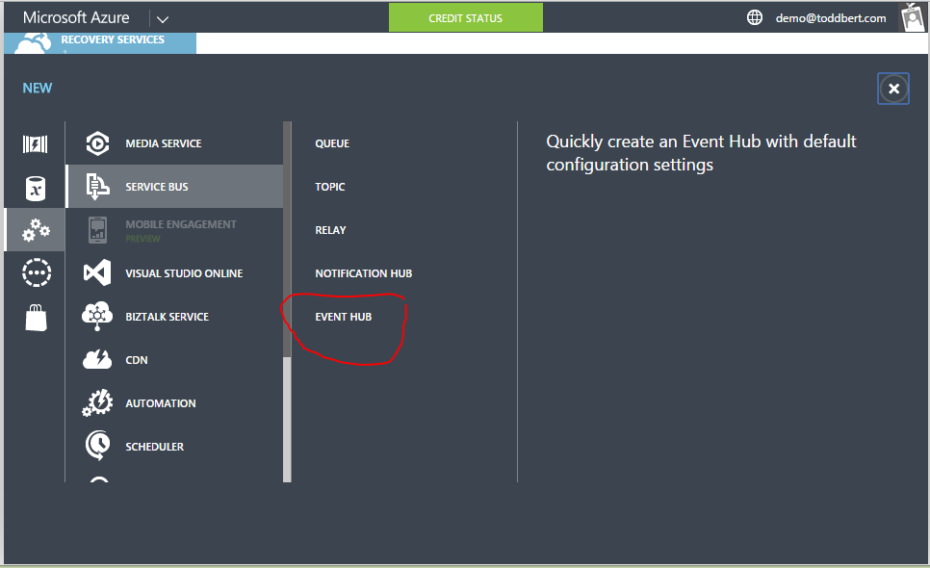
4. Select a name and location for the event hub  
   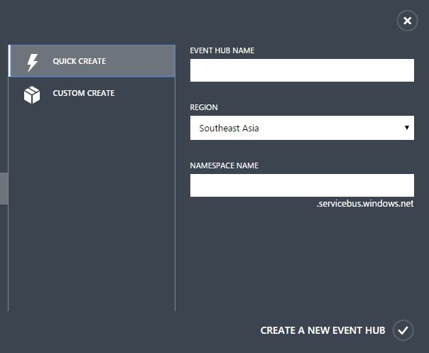
5. Select the newly created Service Bus Namespace _> Event Hubs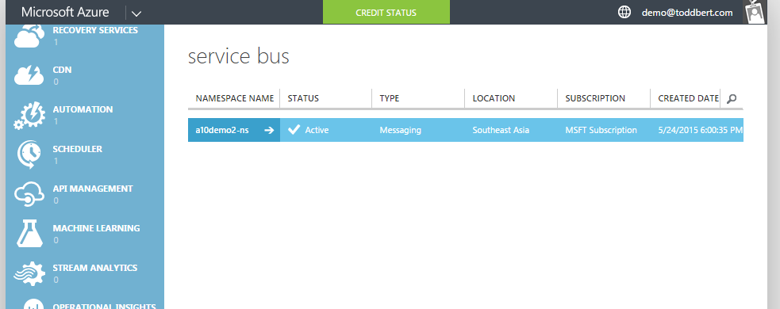
6. Select the newly created Event Hub  
   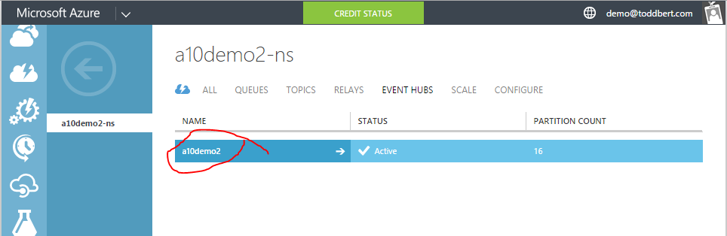
7. Click the Configure Tab  
   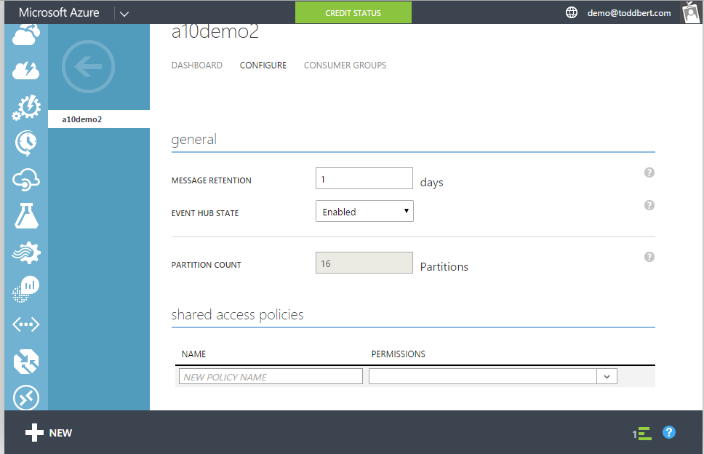
8. Create a Sender Policy with Send Permissions  
   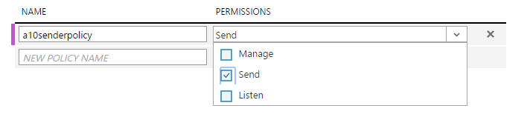
9. Create a manager policy with all permissions  
   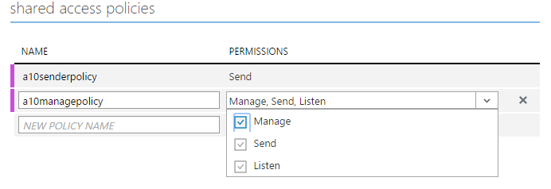
10. Click Save
11. View the newly created keys  
    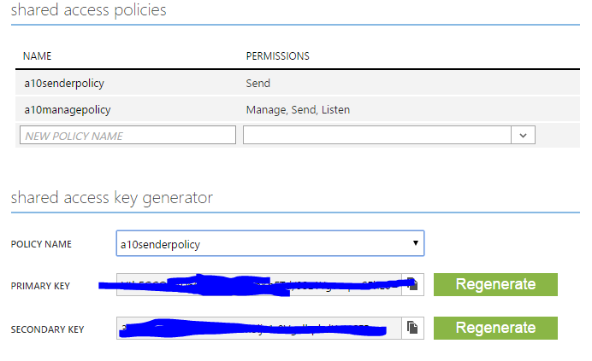
12. Click on the Dashboard TabClick on View Connection String  
    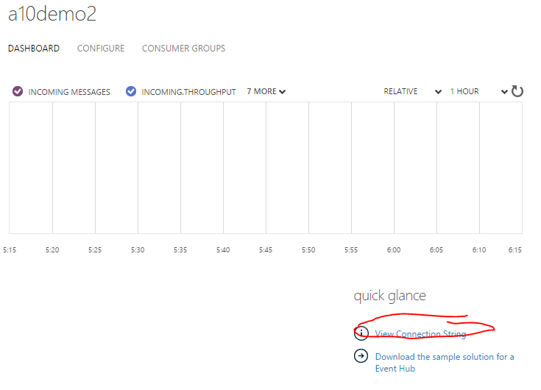
13. Copy the details of both policies to notepad for later use  
    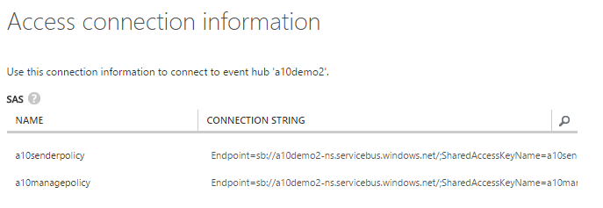
14. Switch to Visual Studio and replace the values in app.config with the name of the event hub and enpoint string associated with sender endpoint  
    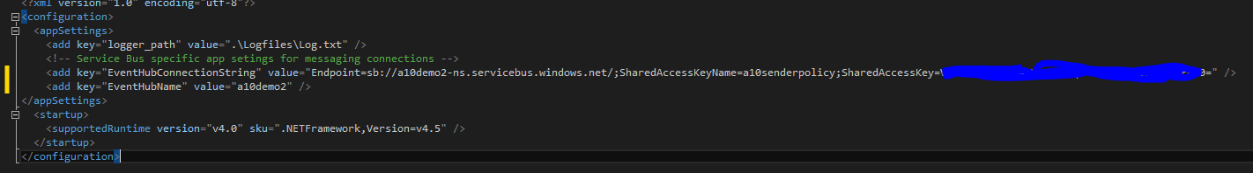
15. Start without debugging to start data seeding, leave it running  
    